Ad Critical Analysis

Ashleigh Shaw

In any given magazine or newspaper, color is present in the advertisements. While flipping through magazines, orange and yellow were frequently used, and thus five of these orange shaded advertisements were used. The first interesting quality noticeable is that in all but one of the five ads analyzed, a white font was used against the orange backdrop. The one anomaly was the Tropicana ad’s use of green. This is important to note because it emphasizes a similarity between nearly all of the ads. More importantly, however, the use of the same **colors** could be a major detractions for some readers who feel this repetition doesn’t deserve to be stopped on while reading a magazine. Tropicana, being the only ad to use a different color, thus creates its own scheme that is repeated on the bottle, in other ads, etc. This is a very successful use of color for Tropicana because in terms of color, it is deliberately different from the other ads.

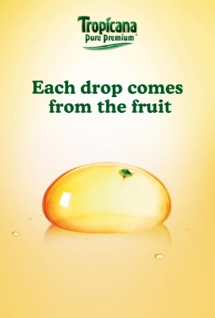

Another quality that several of the ads share is the use of negative space. Negative space is an important technique as it typically draws the viewer away from the color that was previously mentioned, and into the image in the center. This is important for many ads, as they are selling a product. Consequently, advertisers want a reader looking at the product, not determining if they like the color. Many of the ads use the negative space in the same way. For instance, Crush and Tropicana both have a lot of negative space. In both ads, an image of the product or something in relation to the product is in the center, and above the image are the tagline. Here, the use of negative space really forces the focus on the product, and is quite successful because there isn’t a struggle to focus on anything but the image. The Daisy Sour Cream and Sun Chips ads also use a lot of negative space. Sun Chips attracts readers in a similar way to Crush and Tropicana, but there are a lot more words (thus less negative space) which may turn off some readers. In the case of the Daisy Sour Cream, there isn’t a lot of negative space. However, this ad places all of the imagery apart from the main image out of focus. This acts in a similar way to the negative space as the photograph is emphasizing the product and not the background imagery.

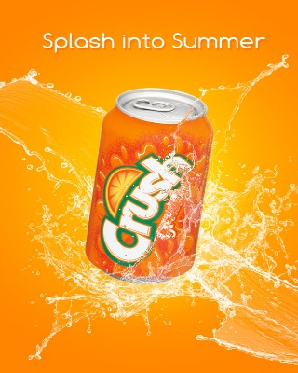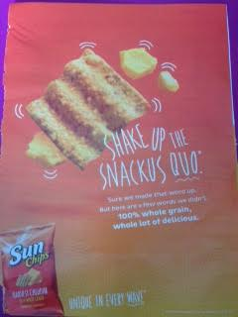

Another element that all of the ads had to consider was the typeface. Although they all had to use at least one **typeface**, the three worth mentioning are the Daisy Sour Cream, the Sun Chips, and the Olay soap. The font used throughout the Olay ad matches the typeface used on the bars of soap and on the containers it is sold in. The only difference that occurs on the ad is the occasional use of bold. It is hard to say whether this helps or hurts the ad, as using the same font creates an immediate connection for people, but it also makes this ad dull because there is nothing interesting to look at. While Olay seemed to struggle with typeface, the Sun Chips and Daisy excelled. Sun Chips did an excellent job of pulling the two fonts used on its packaging into the ad. In particular, one of the fonts is more casual, and thus was perfectly aligned with the “shake-up” phrasing. The angle the typeface alongside the typeface used made it look like the font was dancing alongside the snack. A visually appealing and interesting combination. Daisy, like Olay, used its well-known typeface throughout the ad. Where it became successful was the use of a cursive typeface only once in the ad. This different typeface was used to write out “squeeze”. This is important because Daisy is advertising its new squeeze sour cream product. Thus, Daisy easily made it clear through the typeface that this was a new product the reader should be excited about.

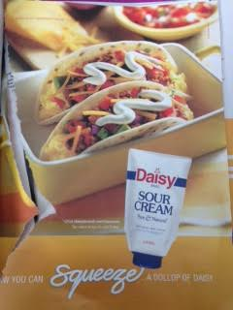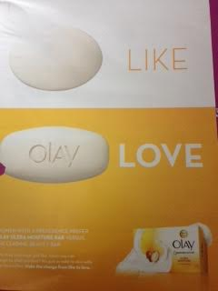

Although there are many similarities, the way the advertisers use their design elements determines how successful they are. The Sun Chips are a very memorable ad because of the typeface used; this can also be said about the Daisy sour cream. The Tropicana ad is probably the most interesting ad of the five in terms of color because it detours from the orange/white combination by using green. The other two ads are not as successful because they lack these eye popping moments or interesting design elements.