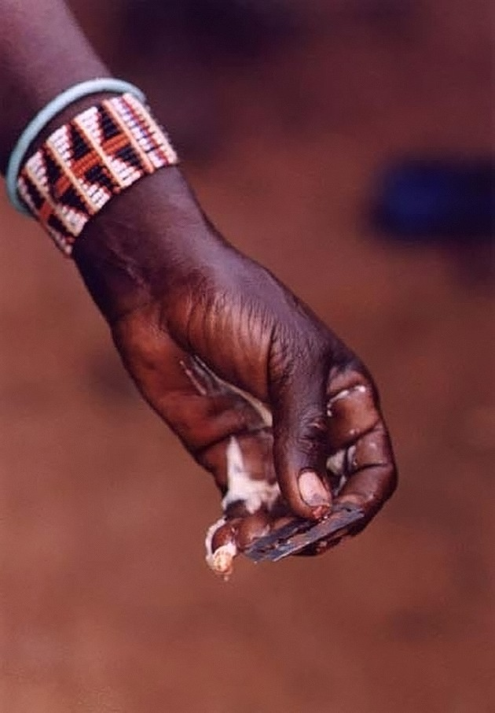Rosie Brodsky

Professor Sarah Menke-Fish

Pulitzer Photo Essay

September 27, 2016

“Kenyan Female Circumcision”

When walking around the Newseum, many pictures struck me due to their complexity and extreme emotion clearly displayed in the still image. Not very many were simple, and most were clear about their subject. This picture requires a backstory, which is what intrigued me at first. Once I read the title of the piece, “Kenyan Female Circumcision”, I felt sadness. Female circumcision is a topic I know well, and actually hate. As a feminist, it goes completely against everything I stand for. This picture struck me as important because female genital mutilation (FGM) is a very common ritual in many African countries as well as a few Middle Eastern and Asian countries as well. I was drawn to this photo for its intriguing simplicity of a convoluted and little-known subject matter.

This photo, from 1996 by Stephanie Welsh, depicts simply a hand with a bracelet, and what appears to be a razor between the fingertips. There is some sort of white substance on the side of the hand as well. It seems unsanitary because whomever the hand belongs to is not wearing gloves and the razor itself is not clean. The color stands out very much in this photo. The darker skin of the hand is similar to the color of the background but still stands out because of the high contrast in resolution and clarity. The hand is on a diagonal line, which simulates movement. This makes it seem as though the hand is in motion, perhaps just after one of the cuts. The texture in this photo is also striking. The lines and folds on the hands and the clarity of the beads make this photo relatable. It is so up close and personal that this person doing the cutting seems less like a monster and more like one of us. There is no frame and no other objects in the photo besides the hand, bracelet, and razor. This signifies the importance of these objects and nothing else. This shot is a close-up because the photographer didn’t want to include anything that would complicate her photo. She wanted just the two weapons of mutilation and the reminder that this act was committed by a woman to another woman.

This image was taken in Kenya in 1996. It captures the illegal ritual of female genital mutilation. This photo was part of a series by photographer Stephanie Welsh. In the other photos, the object of the abuse is captured after the mutilation, with blood covering her feet and the ground, and again, looking at her disfigured body. There is also a photo of her elders forcing her down while she attempts to break free because she is in so much pain. It was not dangerous for Welsh to get this photo, but emotionally it was difficult. She spoke after winning the prize about how she wanted to help the girl she saw, but could not as it was not her place. She actually went on to be a midwife and female health activist. Welsh went to Africa on assignment and decided to learn about and document the process of FGM. Even though her editors were uninterested, she went through with it anyway. The Nation printed a watered-down version of her story, so continued to work on it and eventually got it published in full detail. Welsh has also done stories on forced and child prostitution in Northern Africa.

I believe this image was taken to raise awareness about a taboo subject. Many people don’t even know what FGM is or how it works, and others believe that since it is illegal that it doesn’t happen. The risks that come with FGM are extremely high and the rewards few. Many of the rewards are cultural and if a female somehow gets out of doing it, she will be ostracized and excluded from her community. This is a difficult line because it is not American culture. It is difficult for anyone outside of Kenya to fully understand the reasons behind FGM. Even though it is an important part of their culture, it is still illegal and for good reason. FGM has many complications, both short and long term. It also has sexist implications, as it is a method of controlling females and their sexuality. Male circumcision is different because the male sex organ and the male function normally without the foreskin. It is also relatively painless and the removal has many associated health benefits. FGM completely destroys the female sex organ. Women die often from this procedure, not only because it is performed by untrained town members with unsanitary conditions, but also because it causes many problems with bleeding, clotting, and even urinating. I believe that Welsh was trying to make a statement about FGM simply by educating people on the fact that it exists. This photo has probably encouraged hundreds of thousands of people to look up FGM and why it matters. Welsh followed ethical guidelines. She did not intervene in the process and did not make a statement about whether or not she approved of it. She simply took a photo of the instruments used and implored people to learn and come to their own conclusions.

I liked this photo because it was simple and non-political but was deep at the same time. FGM is almost hidden from the world in a sense. It also shows an event that happens regularly and not just a one-time thing, like some other Pulitzer Prize photos. The story behind the photo was scary and eye-opening. The photo was almost peaceful, which contradicted the event that had taken place probably thirty seconds before it. It encourages education and activism without directly saying so. This photo definitely deserved to win the Pulitzer Prize for both its composition and deeper meaning.